Prototype-CPL

|  |  |
| --- | --- |
| **Student Name/ID Number:** | Muhammad kemal |
| **Academic Year:** | 2023 |
| **Unit Assessor:** | Arvinder Kaur |
| **Project Title:** | CPL-Project prototype |
| **Issue Date:** | September 6, 2023 |
| **Submission Date:** | September 7, 2023 |
| **Internal Verifier Name:** |  |
| **Date:** | September 7, 2023 |
| **Project Title:** | "Enhancing Features and Revitalizing Jumpstart Website to Fit Post-COVID-19 User Preferences" |

|  |
| --- |
| **Learner declaration** |
| I certify that the work submitted for this assignment is my own and research sources are fully acknowledged.  September 7, 2023  Student signature:  Date: |

**Project Prototype**

Landing Page

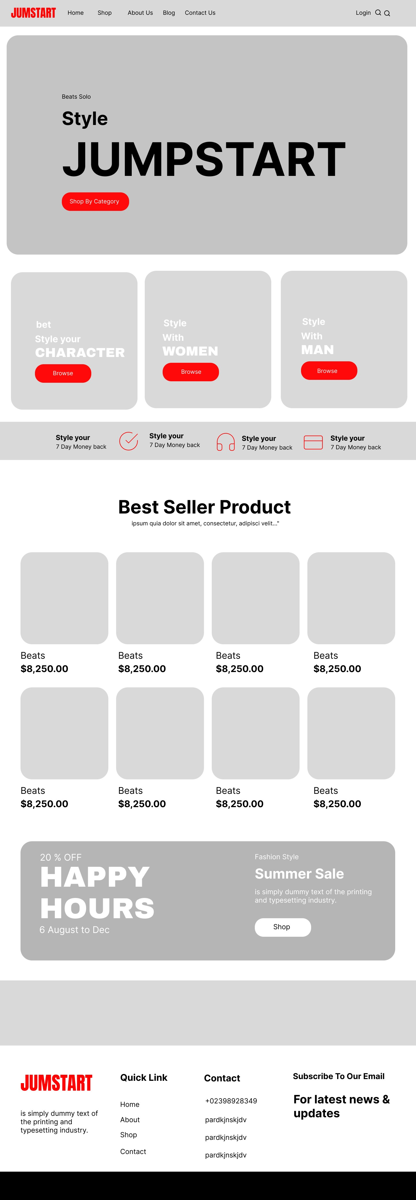

About Us

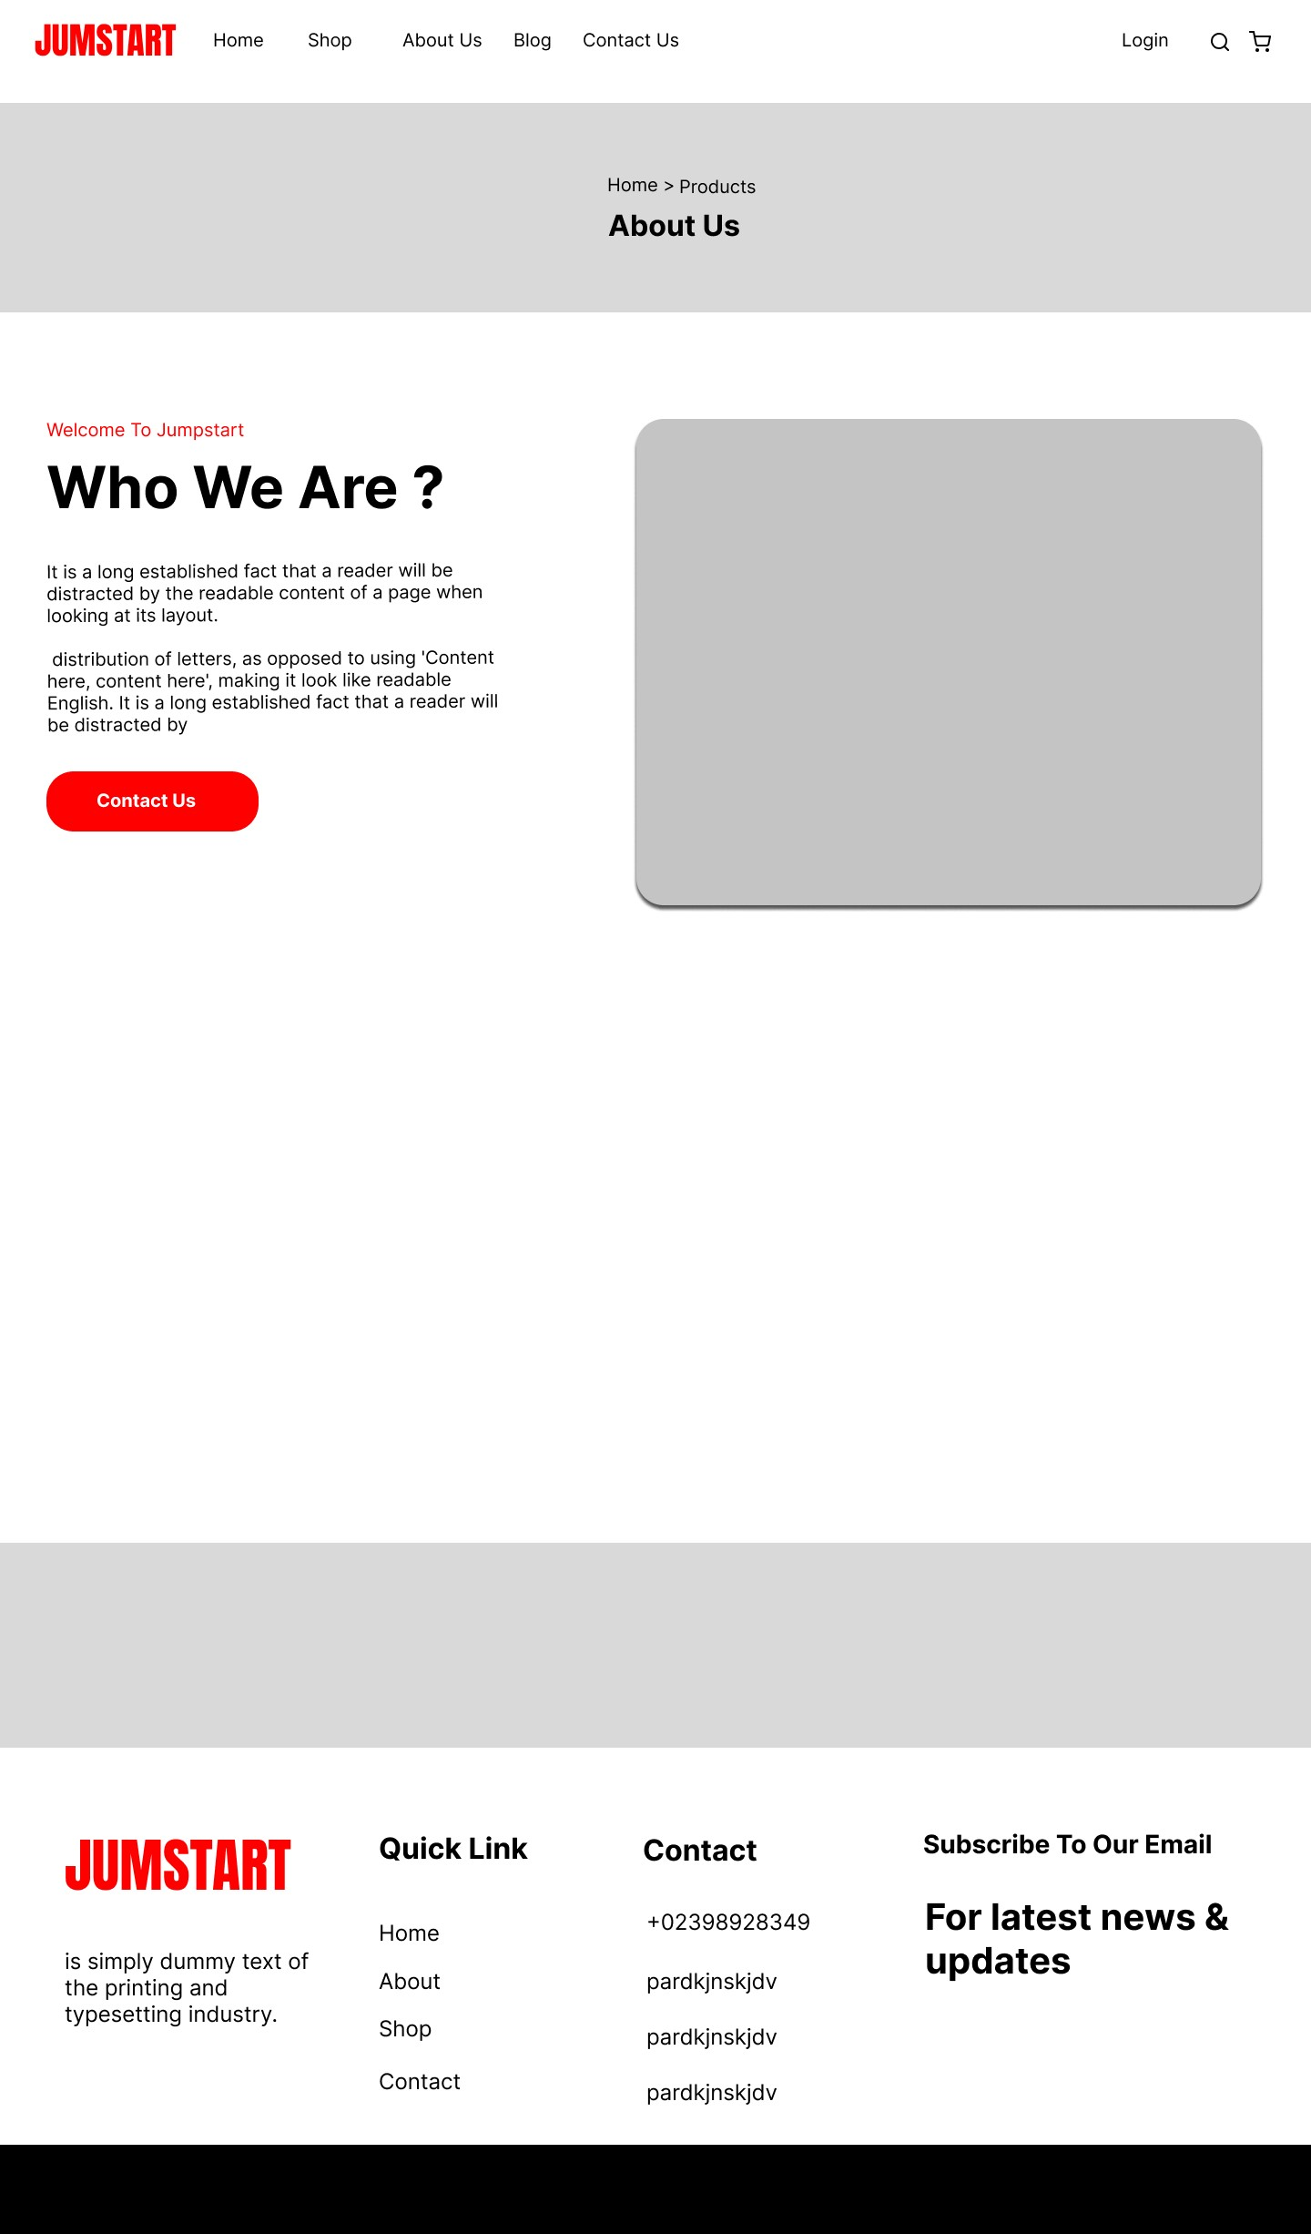

Contact Us

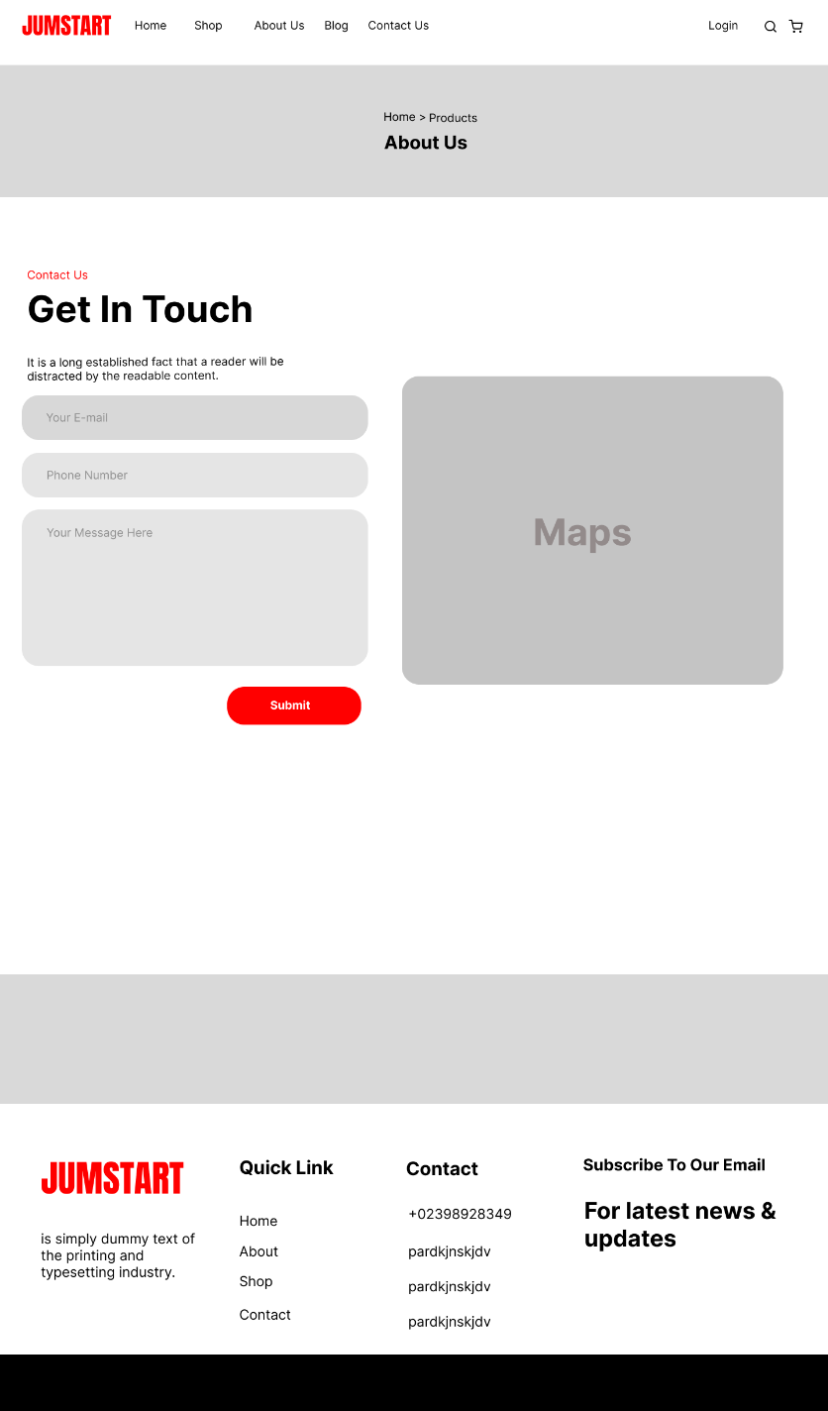

Register  
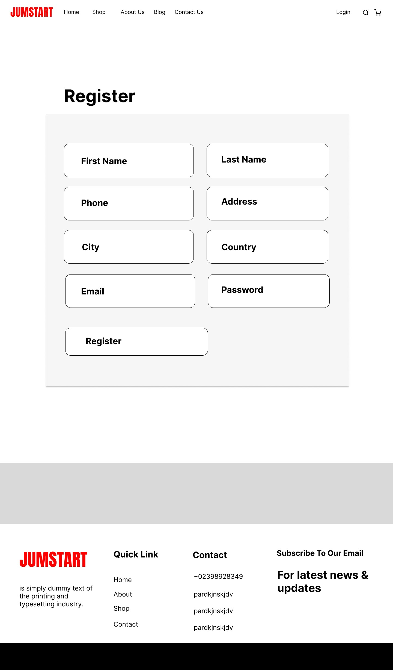

Login

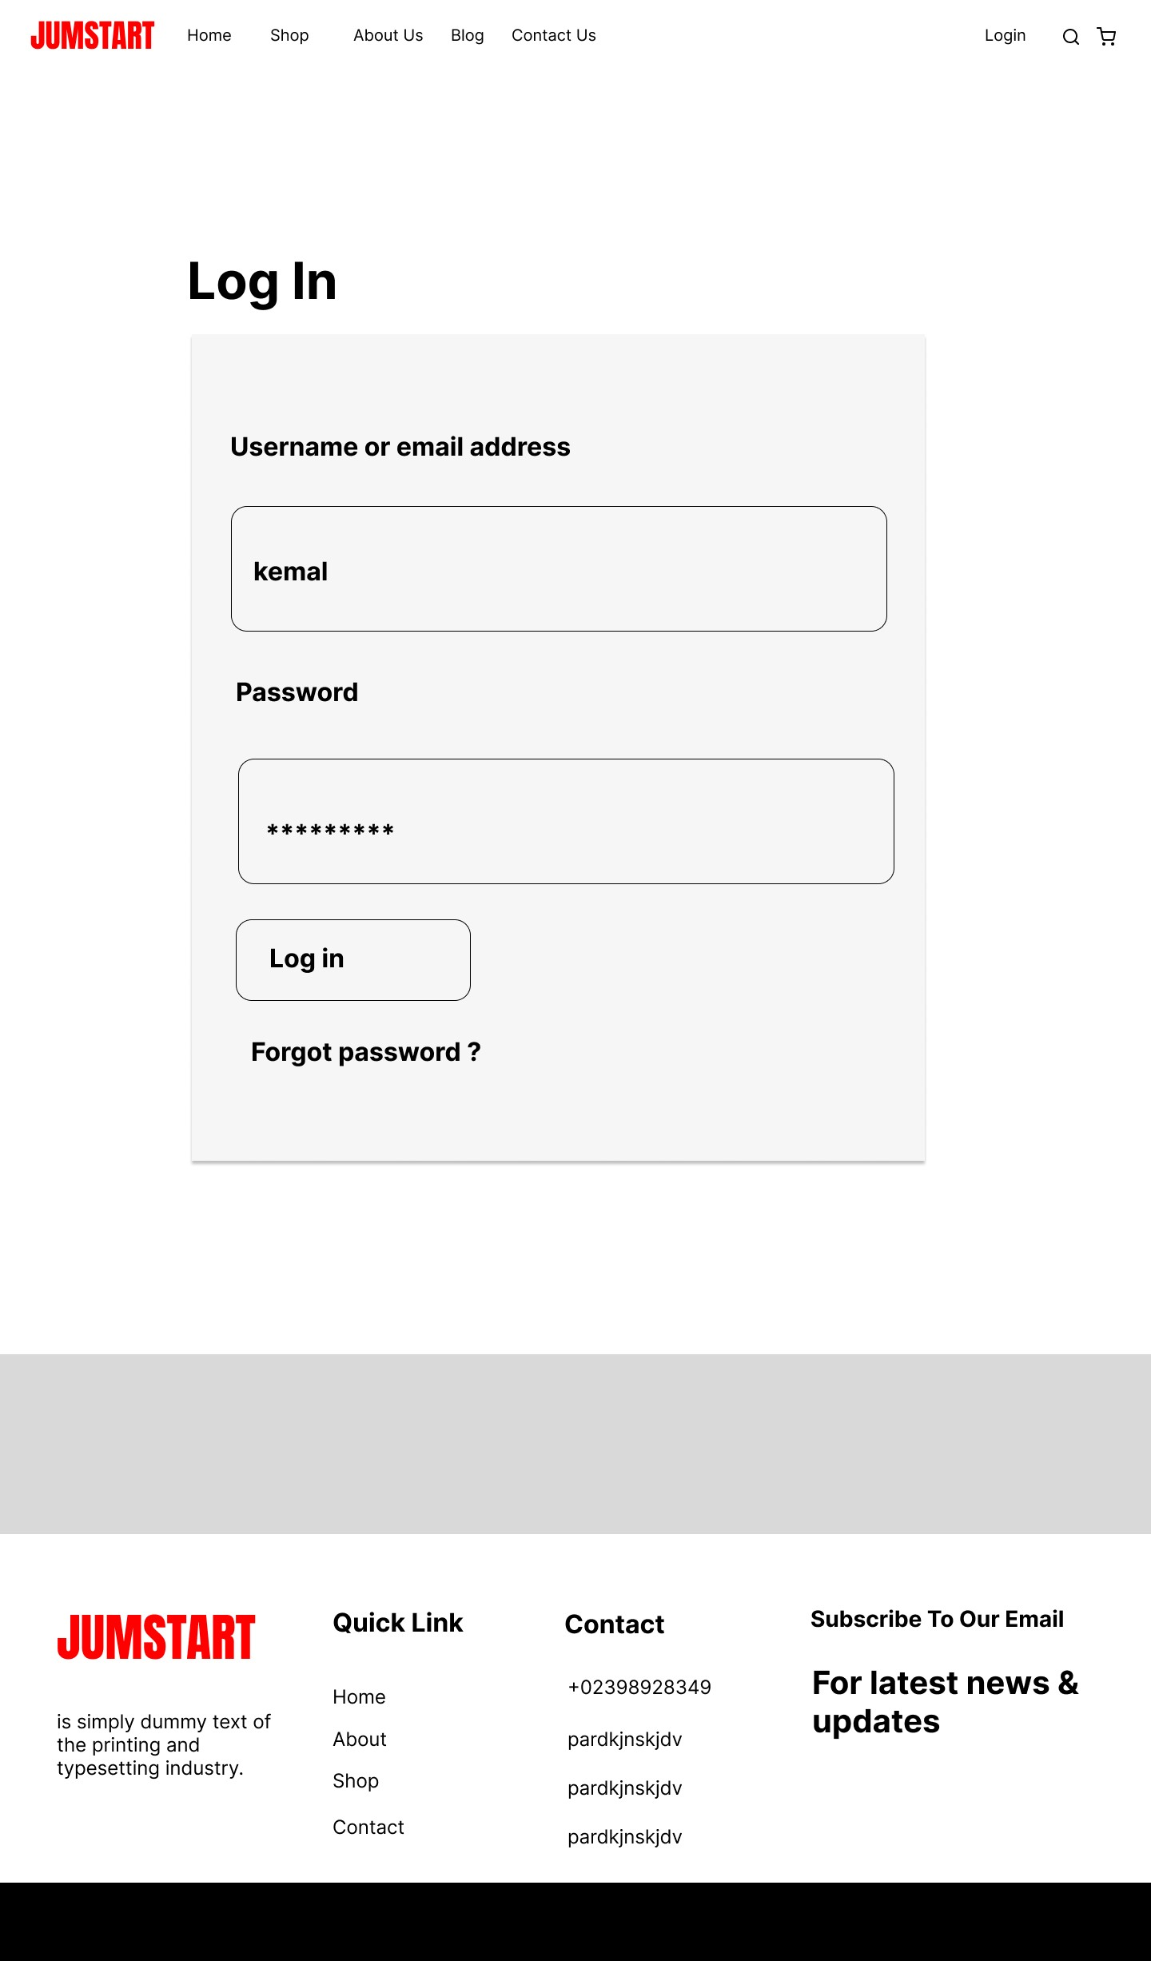

Shop

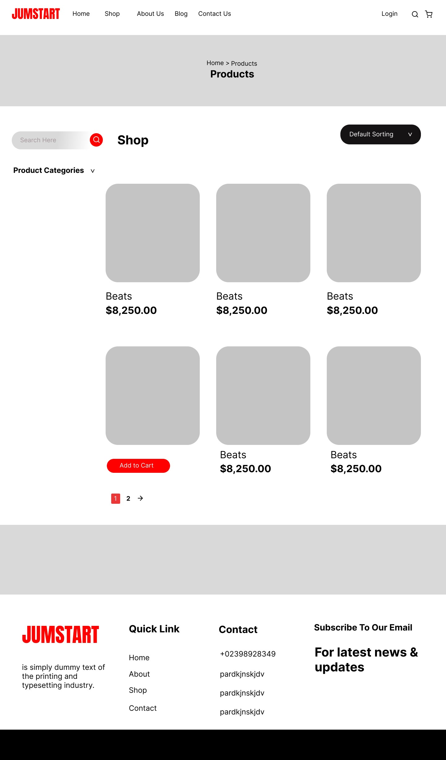

Details Product

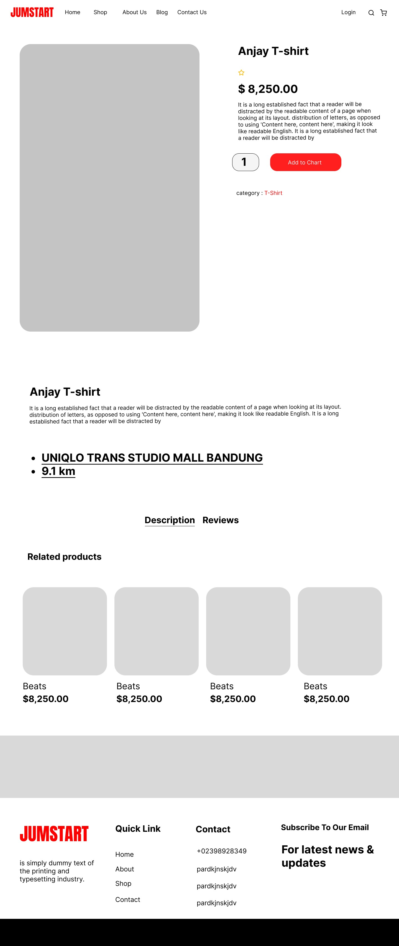

Cart

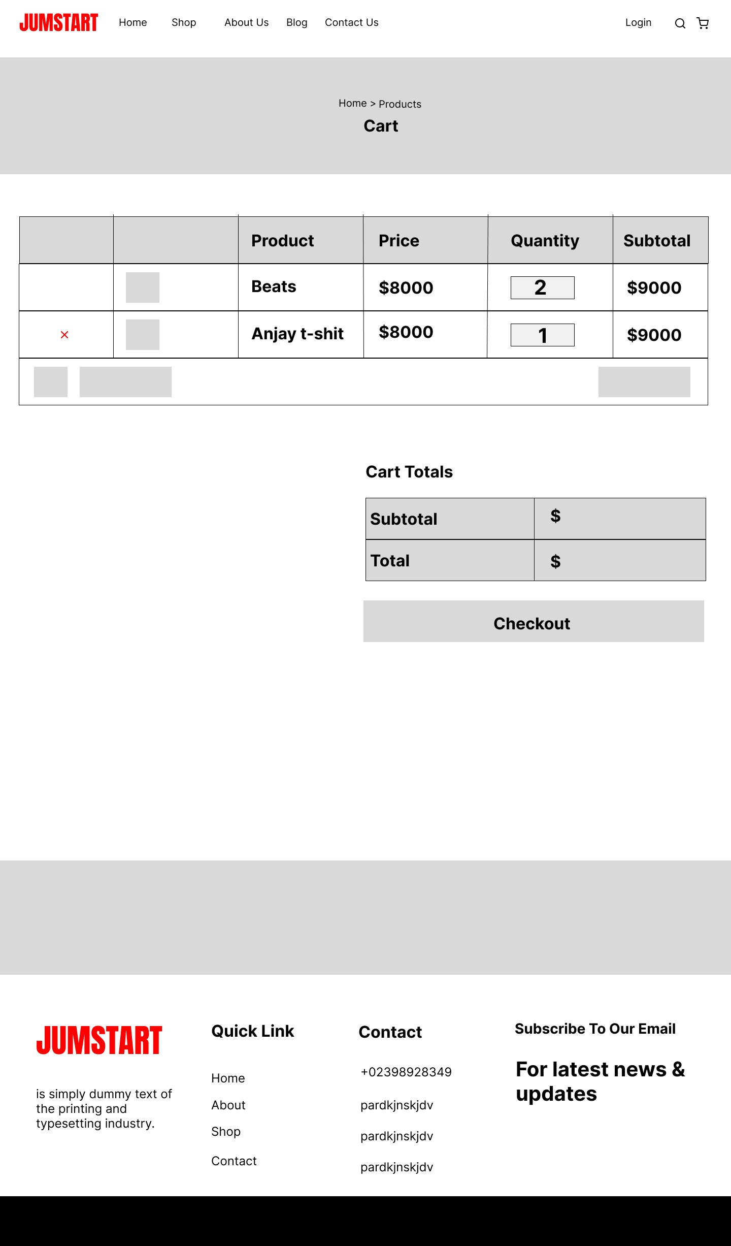

Checkout

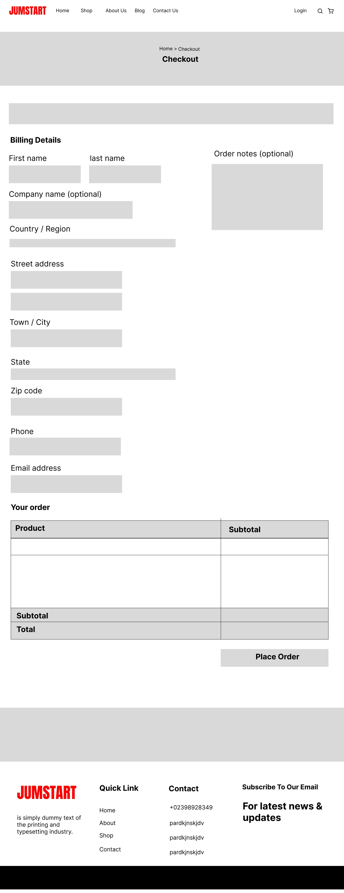

Dashboard Admin

